
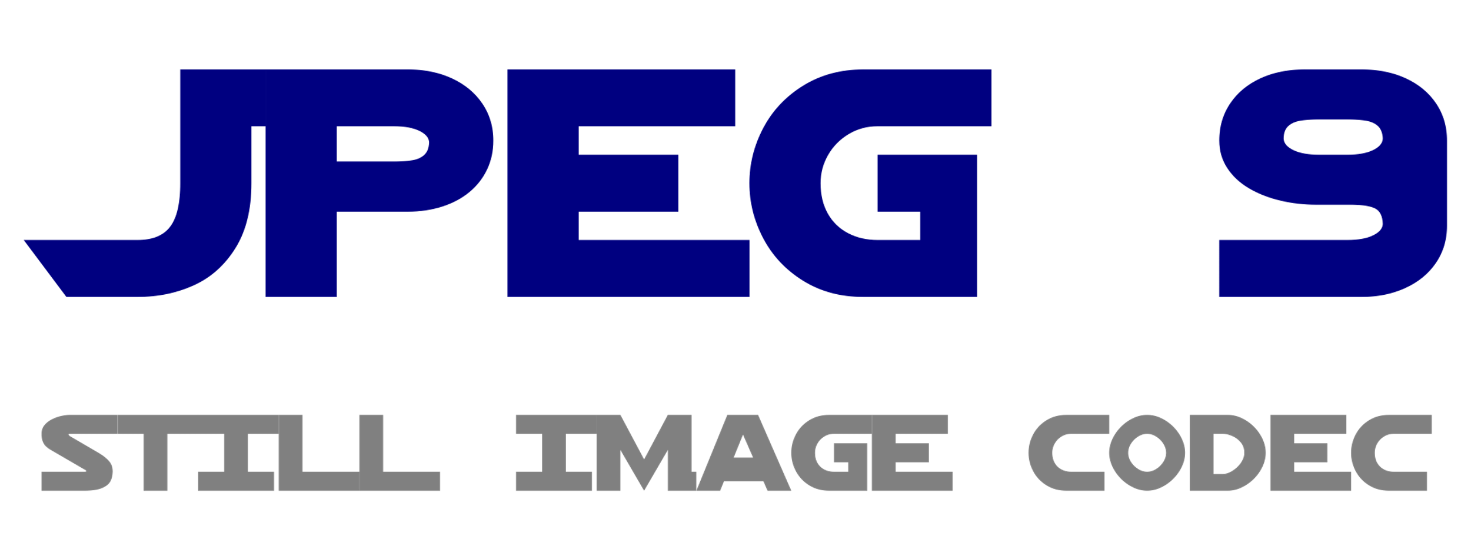
Happy Birthday JPEG!

The most successful electronic
image format becomes 30 years old

It is hard to find superlatives to describe the success story of the JPEG image format appropriately. At every tourist feature happen, technically speaking, virtual JPEG orgies day-to-day. Hundreds, thousands of files in this format are generated in every hour on the Place de Paris in Berlin, when tourists snapshoot each other with their smartphone in front of the Brandenburg Gate, on the party, when taking mutual snapshots and selfies, and also in the professional photographic laboratory, where raw photographs are developed to JPEGs. It is difficult to estimate how many JPEGs are generated worldwide every day, but one thing is certain: They are several billions. In many cameras und most mobile phones it is unavoidably the only format in which images can be saved. In social media networks JPEGs are uploaded almost exclusively. According to statistics from the year 2014 they are nearly two billion day-to-day. If it’s about the number of generated files, JPEG is the most successful electronic media format of all times.
When the Independent JPEG Group (IJG) released the first version of libjpeg, a reference library for JPEG applications, on October 7th 1991, nobody had a rough estimation about the upcoming success story of this format. The Joint Photographic Experts Group, which was established in 1986, assigned the IJG to write this library with certain obligations. The goal was to reuse procedures of existing image processing applications and provide a kind of ready-made toolbox for image manipulation. One of the obligations was that the produced library shall be open-source and freely available, another that the compression method shall be based on the Discrete Cosine Transform (DCT). Tom Lane of the Independent JPEG Group implemented the requirements by writing a program library which could be used in many applications and which was mainly responsible for the widespread adoption of the format.
1991 was in many respects a fateful year which should shape the digital future of mankind in the following decades. Tim Berners Lee published the first website and thus marked the origin of the World Wide Web. Meanwhile there exist more than a billion websites worldwide. Linus Torvalds provided the internet community a prototype of a small operating system which developed to Linux, one of the dominant server operating systems. This is another case of a legendary success story. Linux became one of the most important operating systems for internet server and is widely-used as core of the operating system Android on more than 80 percent of all smartphones. All three inventions, the Web, Linux, and JPEG, stimulated one another. The Web prospered at a tearing pace, supported by countless Linux servers. And the fact that mainly GIF and JPEG images could be used in websites accounts for the popularity of the format.
Idea
An important feature of JPEG is the efficient compression method. The preliminary events leading up to these methods of media compression lead us back to the seventies. 1972 the American National Science Foundation refused to fund a proposal to investigate the so-called Discrete Cosine Transform (DCT). One reviewer’s comment to the effect was that the whole idea seemed „too simple”. An Indian named Nasir Ahmed, who was with Kansas State University at that time, wrote the proposal. Without funding and only with modest confidence about the success of the research direction he decided to continue the investigations. In 1974 he obtained surprising results which „appeared too good to be true”. Further inspection confirmed the excellent results. To date every common method of media compression, including the one of JPEG, is based on this procedure.
Dawn
The Independent JPEG Group on their part had not expected that libjpeg 1 would gain popularity so fast after publication. At a fast pace further versions were published which gave the software more reliability, security, and performance. So already in 1993 libjpeg 4 arises, the fourth main release. Subsequent versions carefully introduce new features such as successive approximation (progressive coding) as well as the option to rotate images without loss of quality. Version 6 was released in 1998 and remained in effect for over ten years. This era is marked by the rising popularity of the World Wide Web and digital cameras, which now became affordable for the average consumer. Both events support the extremely fast propagation of the JPEG standard.
Prosperity
In 2005 Tom Lane transfers the leadership of the Independent JPEG Group to Guido Vollbeding. Vollbeding had already worked with the image format since 1992 and casually contributed routines for libjpeg. The challenge for him was huge. Meanwhile JPEG had deeply penetrated the software as well as the hardware domain. On the one hand he felt confidently home in the domain of DCT and compression methods as a mathematician, on the other hand he had never conducted such a large and important software project single-handedly. Eventually in 2009 he released libjpeg 7, which first of all contained a part of the intended extensions, corrected numerous security defects, and improved the encoding and decoding of images. Versions 8 and 9 integrate further functions such as SmartScale, lossless compression, and the option to address an extended colour gamut. Some of these extensions are already contained in the DCT model latently, it was just necessary to unlock the feature, so to speak.
Vollbeding: „A standard has to evolve to remain standard and meet current requirements. Of course, the development must happen carefully and guarantee at the best the compatibility with existing image files and applications.” He sees the task of the Independent JPEG Group in the unfolding of the potential which is already latently contained in the original JPEG format. „There is already a gradually growing number of important reference applications which support the current development state. The next steps are to acquire further software vendors, particularly browser vendors, to adopt long overdue standards such as a more efficient (arithmetic) coding for improved compression. The SmartScale function can simplify communication in the mobile domain. Camera vendors can use features of the new library such as colour gamut extension or the option of lossless compression.”

Authors:
Dr. Lars Göhler, eastpress media (eastpress.de)
Guido Vollbeding, Institute for Applied Informatics (InfAI, infai.org),
Independent JPEG Group (ijg.org, jpegclub.org/reference/)
Leipzig, October 2021

